Ec2 – Challenge
First Challenge
- Launch one EC2 instance using Amazon Linux 2.
- Install Docker.
- Install Jenkins.
- Install Apache.
- Install Nginx.
- Install Apache Tomcat.
Everything needs to be setup and running on the same EC2.
- Launch one EC2 instance using Amazon Linux 2023
Required Security Groups (Inbound Rules)
SSH : 22 your IP to connect to ec2 using ssh
HTTP : 80 0.0.0.0/0 for nginx
Custom TCP : 8080 0.0.0.0/0 for Jenkins
Custom TCP : 8081 0.0.0.0/0 for apache (httpd)
Custom TCP : 8082 0.0.0.0/0 for tomcat
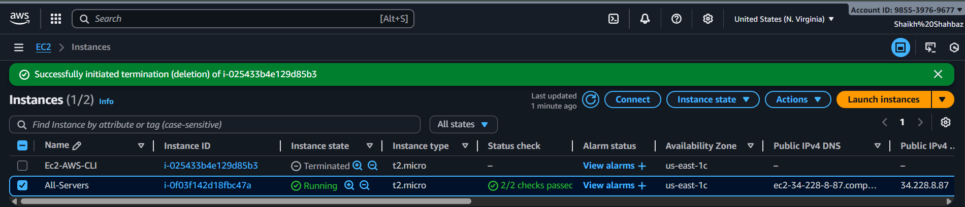
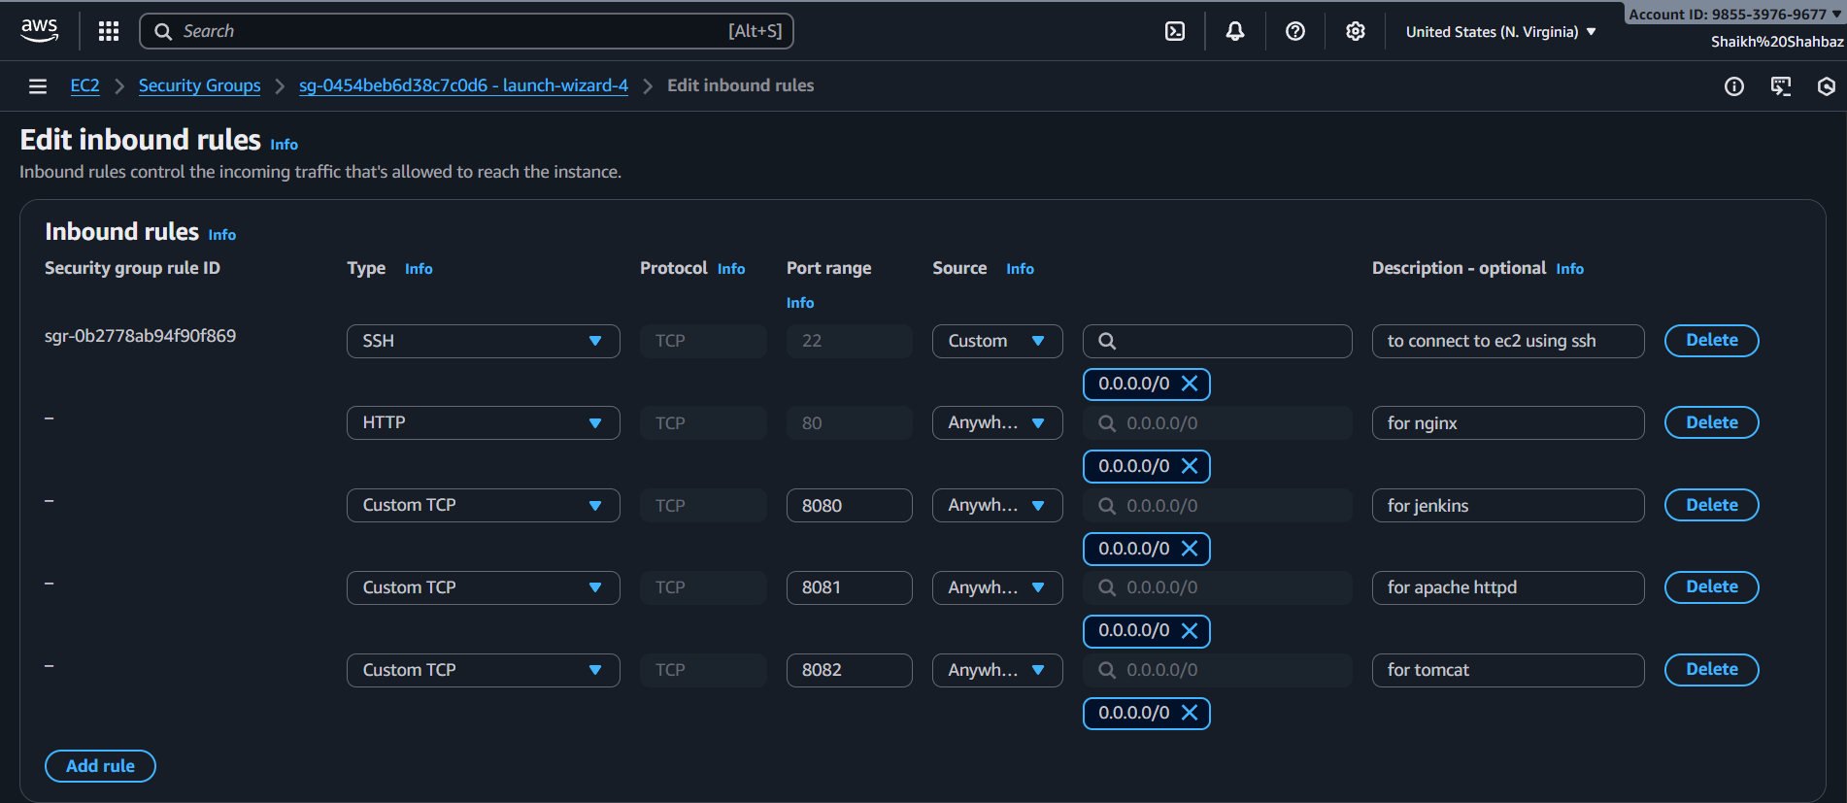

Connect to the server in git bash :
ssh -i "avengers.pem" ec2-user@ec2-34-228-8-87
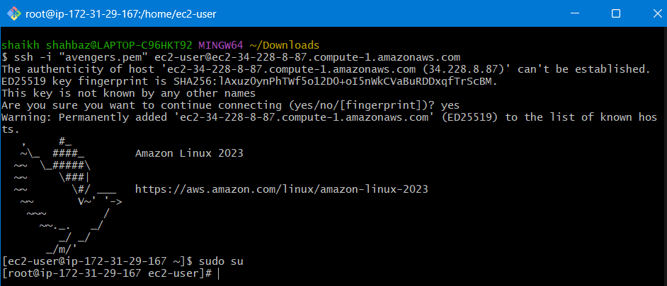
Update Server
yum update -y
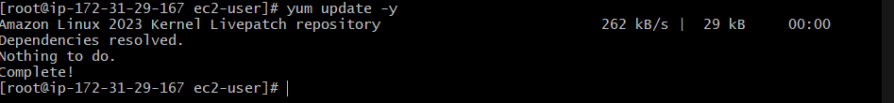
Install Docker
yum install docker -y
systemctl start docker
systemctl enable docker
systemctl status docker
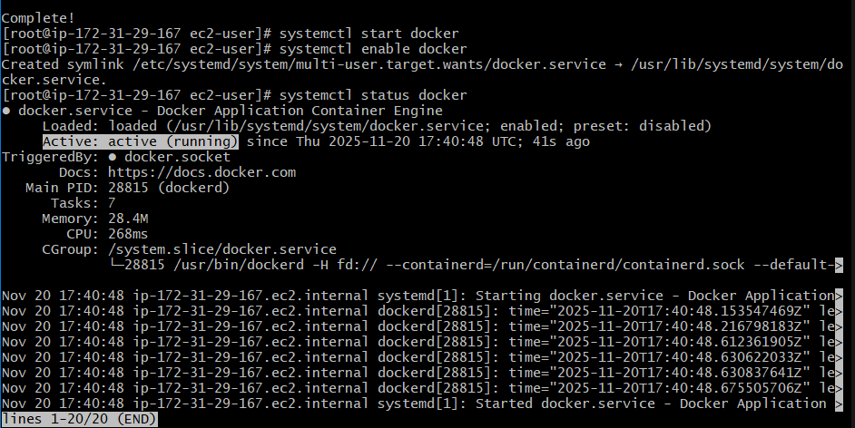

Install Java (needed for Jenkins and tomcat)
yum install java-17-amazon-corretto -y
java –version
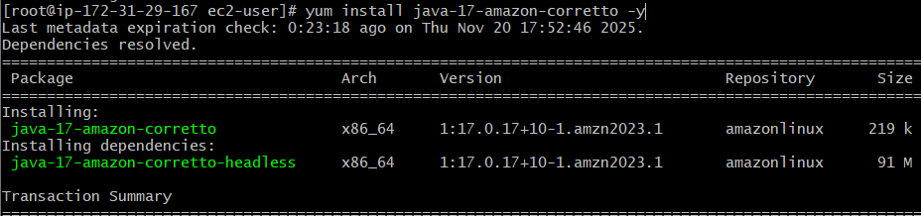

Install Jenkins (runs on port 8080)
wget -O /etc/yum.repos.d/jenkins.repo https://pkg.jenkins.io/redhat-stable/jenkins.repo
rpm --import https://pkg.jenkins.io/redhat-stable/jenkins.io-2023.key
yum install fontconfig java-11-amazon-corretto
yum install Jenkins -y
systemctl start jenkins
systemctl enable jenkins
systemctl status jenkins
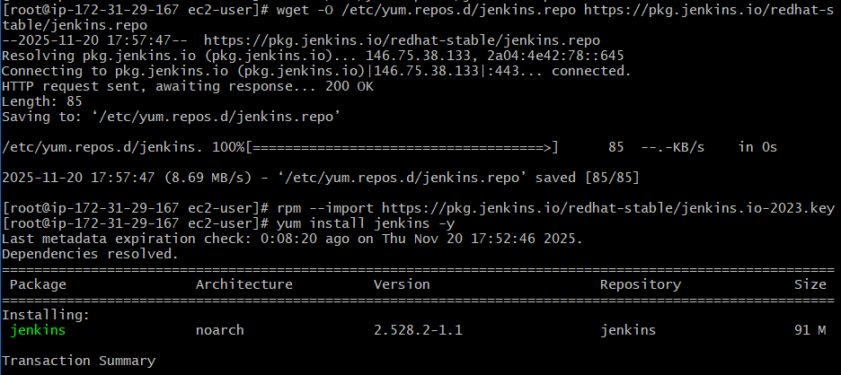
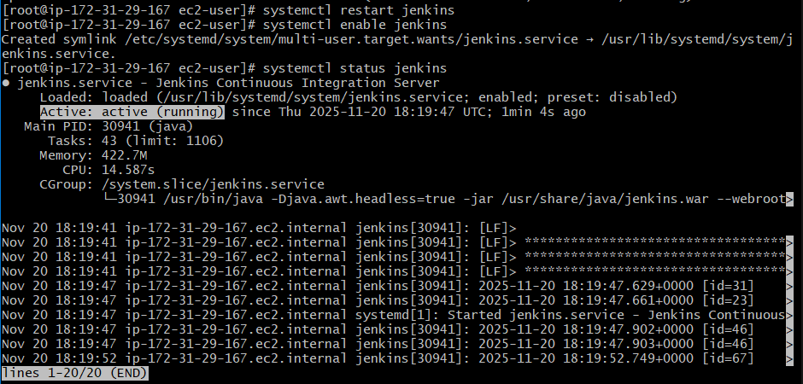
Check on Browser : http:// 34.228.8.87:8080
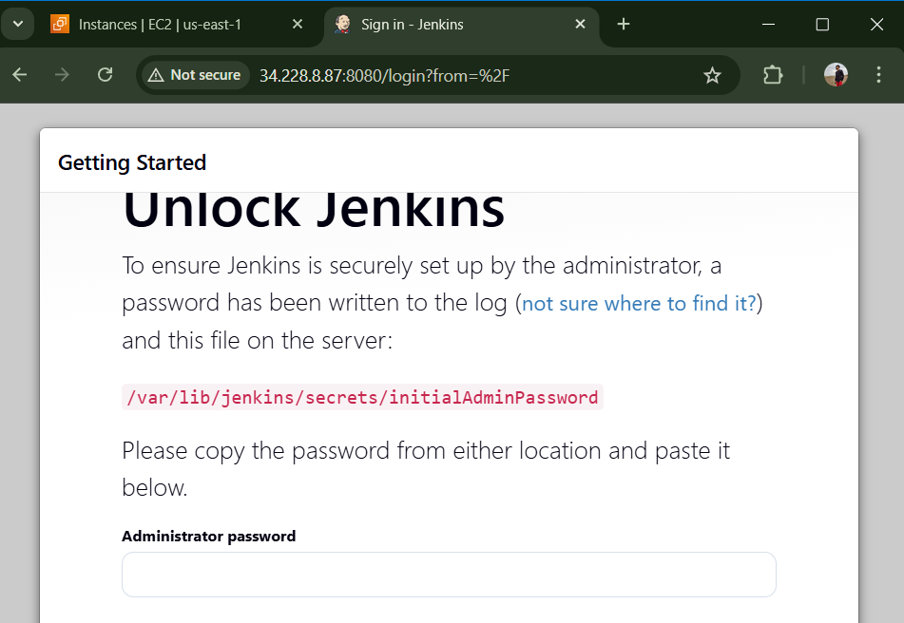

Install Apache (httpd)
yum install httpd -y
systemctl start httpd
systemctl enable httpd
systemctl status httpd
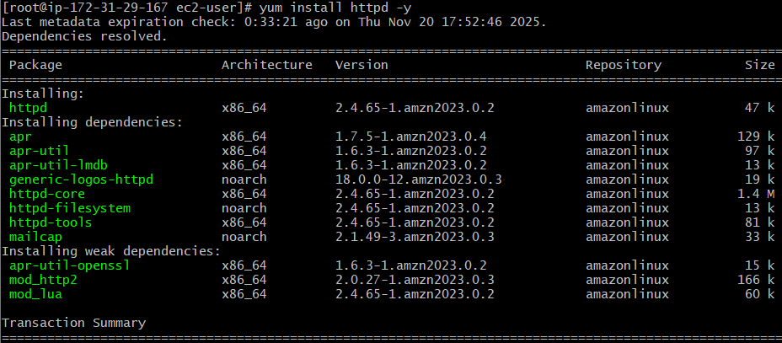
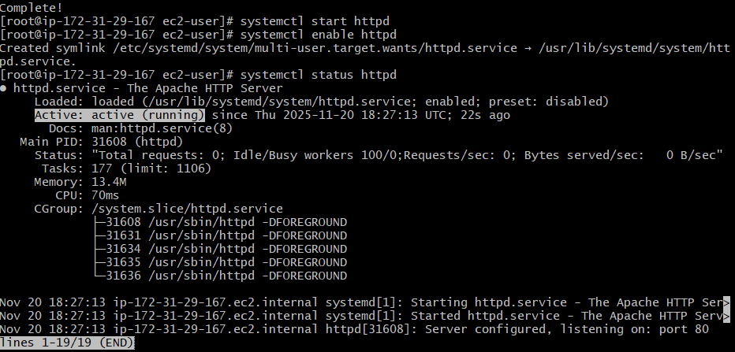
Check on Browser : http:// 34.228.8.87:80
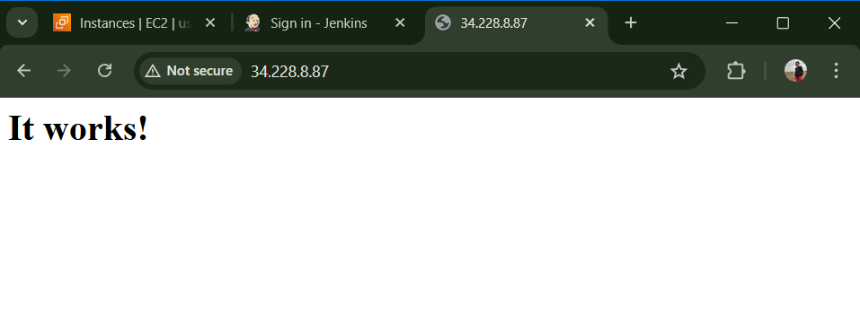

Install Nginx
yum install nginx -y
systemctl start nginx
systemctl enable nginx
systemctl status nginx
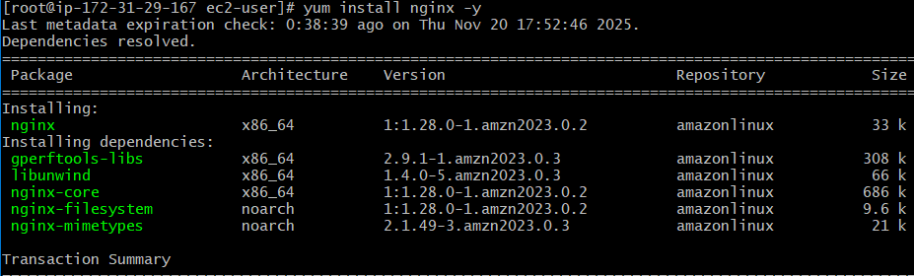
Apache and Nginx cannot run together on same port
To change port number to 8081 use command
sed -i 's/Listen 80/Listen 8081/' /etc/httpd/conf/httpd.conf
systemctl restart httpd
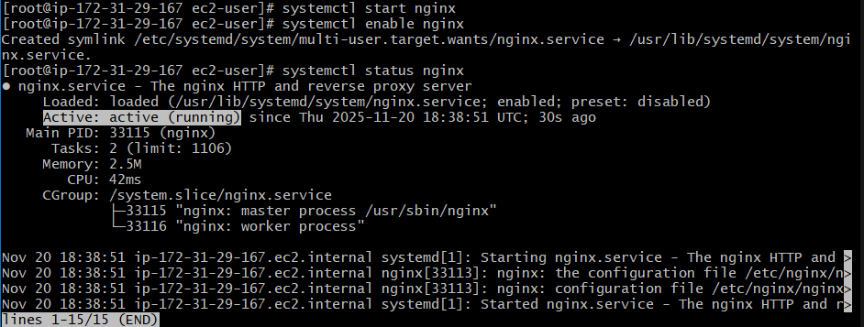

Check on Browser : http:// 34.228.8.87:8081
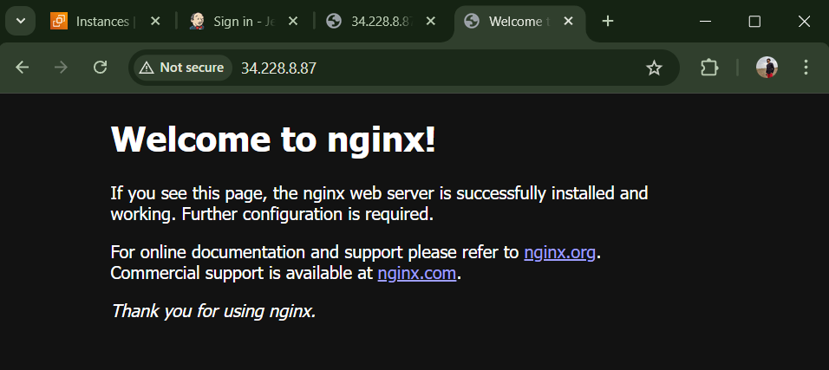

Install Tomcat
cd /opt
wget https://dlcdn.apache.org/tomcat/tomcat-9/v9.0.112/bin/apache-tomcat-9.0.112.tar.gz
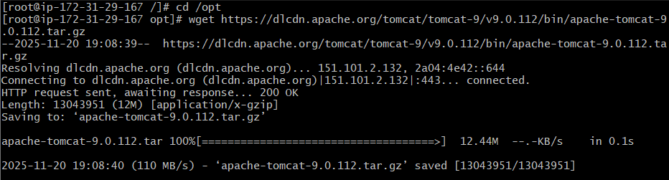
tar -xzf /opt/apache-tomcat-9.0.112.tar.gz -C /opt
mv /opt/apache-tomcat-9.0.112 /opt/tomcat
chown -R tomcat:tomcat /opt/tomcat
chmod -R 755 /opt/tomcat
chmod +x /opt/tomcat/bin/*.sh
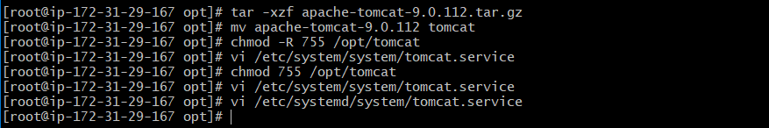
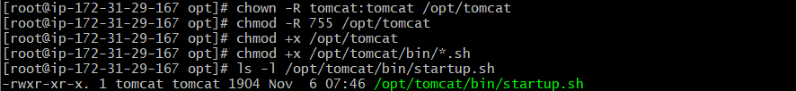

vi /etc/systemd/system/tomcat.service
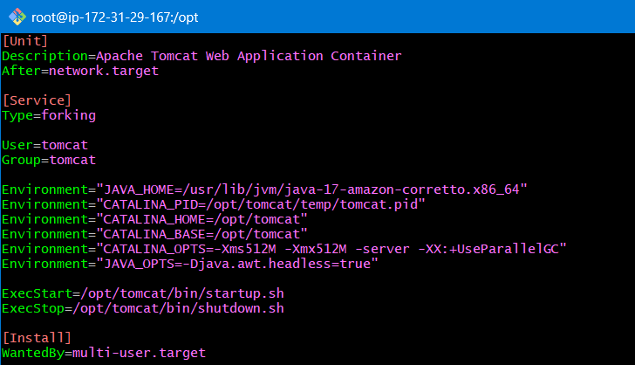
systemctl daemon-reload
systemctl start tomcat
systemctl enable tomcat
systemctl status tomcat
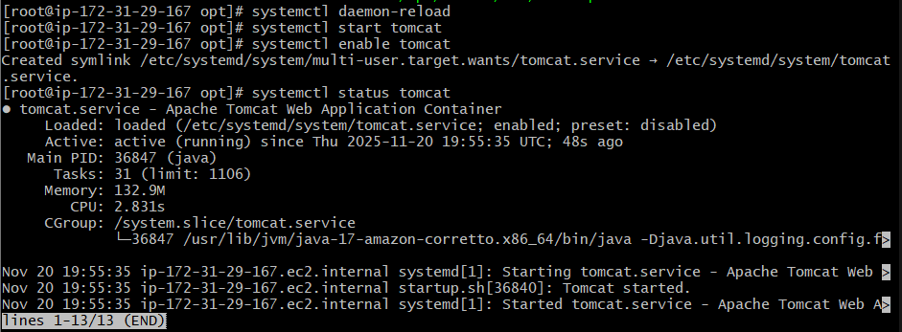
Jenkins is already using port 8080 so change port to 8082
sed -i 's/port="8080"/port="8082"/' /opt/tomcat/conf/server.xml
systemctl restart tomcat

Check on Browser : http:// 34.228.8.87:8082
